Cloud Architect, Cloud Developer, Cloud DevOps Engineer

Compute

**Lab Details**

1. This lab walks you through the steps to create and configure an Amazon EC2 Auto Scaling with Launch templates using the AWS Management Console.
2. You will practice using Amazon Machine Image (AMI) to launch Amazon EC2 Instances using Launch templates and will use key pairs for SSH authentication to log into your instance.
3. You will create a web page and publish it.
4. Duration: **55 minutes**
5. **AWS Region: US East (N. Virginia) us-east-1**

**Architecture Diagram**

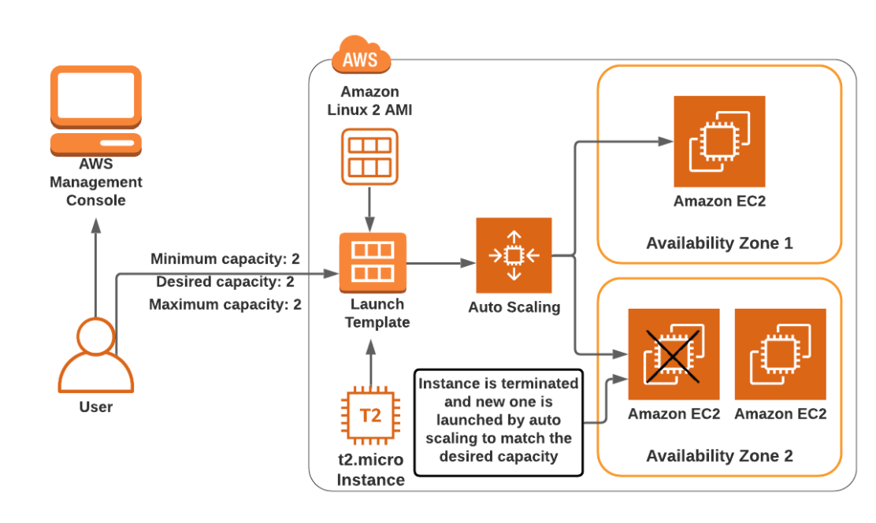

**Task Details**

1. Sign into AWS Management Console.
2. Create a security group for Launch template
3. Create a key pair for the Launch template.
4. Create a launch template
5. Create an EC2 Auto Scaling group
6. Test Auto scaling group
7. Validation of the lab
8. Deleting AWS Resources

**Launching Lab Environment**

     1. To launch the lab environment, Click on the  button.

     2. Please wait until the cloud environment is provisioned. It will take less than a minute to provision.

     3. Once the Lab is started, you will be provided with **IAM user name**, **Password**, **Access** **Key**, and **Secret** **Access** **Key**.

**Note** : You can only start one lab at any given time